TITLE (14 pt)

Author Name^{1(*)}, Author Name², Author Name^{1,2} (10 pt)

¹ Affiliation, Address, ORCID
² Affiliation, Address, ORCID

^{(*)} Corresponding Author Email: yyyyy@zzzzz.org (10pt)

ABSTRACT
Authors of oral presentations or posters are requested to submit an article ( maximum 6 pages) in English. The article must include the title, author(s), abstract, material and methods, results and discussion, conclusion and references. The manuscript should be prepared on an A4-sized paper with 25 mm margins on all sides and typed with single spacing using size 12 Times New Roman font. The abstract should be maximum 250 words. Author should specify at least three keywords to address the study.

Keywords: Keyword1; Keyword2; Keyword3 (minimum 3 keywords)

INTRODUCTION
The introduction should contain brief information about the topic, summary of literature survey and aim and novelty of the study. References in the text should be given according to APA7 citation format (Engelhardt, 2018).

MATERIALS AND METHODS

The materials and the methodology of the study should be stated clearly.

RESULTS AND DISCUSSION
All the tables, images, figures and their headers used in the manuscript should be centered.

All figures, images and figures should be mentioned in the text.

Figures and images should be numbered and figure headers should be placed under the figure or image. Tables also should be numbered and the table header should be placed at the top.

Tables should be designed to have a uniform style throughout the paper, following the style shown in Table 1. Table headers should be in 10pt “Time News Roman” bold and the texts in Table can be set in 9pt “Time News Roman” font minimum.

Table 1. Caption heading for a table should be placed at the top of the table and within table width. (10pt)

 | A | B | C | D
A | Aa | Ab | Ac | Ad
B | Ba | Bb | Bc | Bd
C | Ca | Cb | Cc | Cd
D | Da | Db | Dc | Dd
E | Ea | Eb | Ec | Ed

Figures and images should be in high resolution (minimum 300 dpi). Images should also be named as Figures.

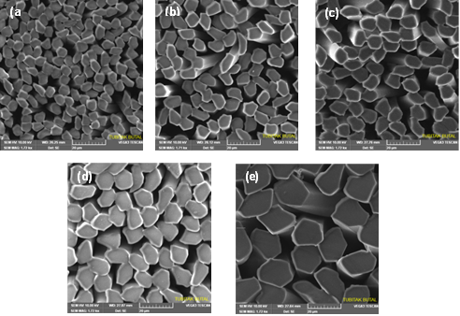
Figure 1. Figure header (10pt)

CONCLUSION

ACKNOWLEDGMENT

REFERENCES
References should be listed according to APA7 style.

